**Smart Expense Tracker**

**Phase 8: Data Management & Deployment**

In this phase, we focus on data handling (import, export, deduplication, backup) and deployment (moving metadata from Dev/Sandbox to Production). The goal is to ensure clean data, reliable backups, and smooth deployments for the Phishing Awareness Training Tracker.

**1. Data Import Wizard**

The Data Import Wizard is used for importing small to medium datasets (up to 50,000 records). For our project, we used it to import initial Expense records.

Steps:

1. Go to Setup → Data Import Wizard → Launch Wizard.
2. Select the custom object Expense__c.
3. Upload the prepared Data.csv file (with Vendor, Category , Status, Note, Source ID, Amount and Date).
4. Map CSV fields to Salesforce fields.
5. Choose record owner option → “Use values from CSV” (we used Salesforce User Email).
6. Run Import → verify in Expense tab.

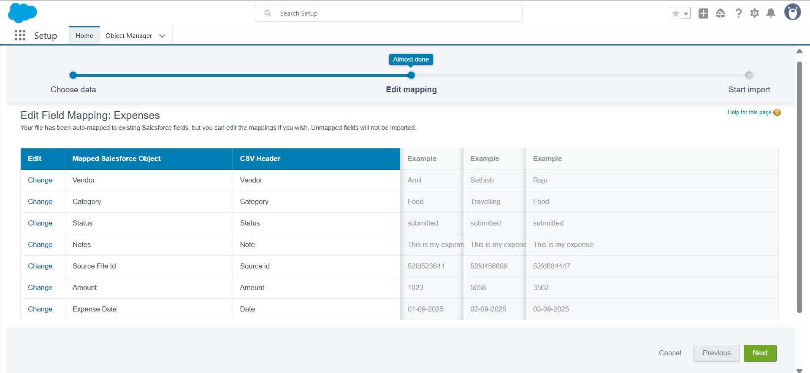

**2. SFDX & VS Code Deployment**

While Change Sets are beginner-friendly, Salesforce DX (SFDX) with VS Code is best practice for developers.

Steps:

1. Install VS Code + Salesforce Extension Pack.
2. Authenticate Org:
3. sfdx auth:web:login -a DevOrg
4. Pull metadata:
5. sfdx force:source:pull
6. Deploy to target org:
7. sfdx force:source:deploy -p force-app
8. Track changes with GitHub for version control.

